Using Golden Age (late era)/ modern terminology
THIS LIST GUIDES SKY-CRAFT FOR GAME PURPOSES,
OCEAN VESSELS OF NEARLY EVERY VARIETY ARE FOUND IN-WORLD
will have to describe options on hulls, decks, and sail plans
Will simplify speeds to windward (50%), downwind (75%), Reaching (100%)
--> Give max speed for reaching from sail plan as well as roll difficulty for each speed
Sail Plans:

Small, 1-Mast:


Cutter: single mast with gaff-rigged mainsail, two headsails, and a gaff topsail above the gaff. Mainmast is aft compared to Sloop. Wind Speed : 20 m/s, Water Speed: 10 m/s. (ND: R = 2, D = 2, W = 4?)
Game Note: Faster than a Sloop, easier downwind and reaching
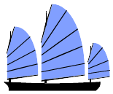
Junk (Single): Durable fore-and-aft rigged sail with reinforcing battens, requires less rigging than other options.
Sky Speed: 10 m/s, Water Speed: 5 m/s (ND: R = 3, D = 4, W = 5?)

Game Note: Slower, hard windward, but cheap, easy to maintain, and easy to
operate reach and ok downwind, and durable

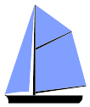
Sloop: single mast with a gaff-rigged mainsail and topsail on the mainmast, which itself mounted foreward compared to the Cutter.
Sky Speed: 15 m/s, Water Speed: 10 m/s (ND: R = 3, D = 3, W = 4?)

Game Note: Good Base Stats, highly maneuvarable, but nothing exceptional. Baseline Model for 1-masts.

Medium, 2-Mast:

Junk (Double): Durable fore-and-aft rigged sails on each mast with reinforcing battens, requires less
rigging than other options.
Sky Speed: 10 m/s, Water Speed: 5 m/s (ND: R = 4, D = 5, W = 6?)

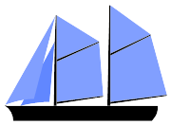
Game Note: Slower, hard windward, but cheap, easy to maintain, and easy to
operate reach and ok downwind, and durable. 2 deck limit

Schooner(Double): Flexible medium size craft with all sails rigged fore-and-aft, foremast is no larger than mainmast.
Sky Speed: 25 m/s, Water Speed: 10 m/s (ND: R = 3, D = 4, W = 4?)

Game Note: easy reaching and windward, but relatively more difficult downwind. Light,
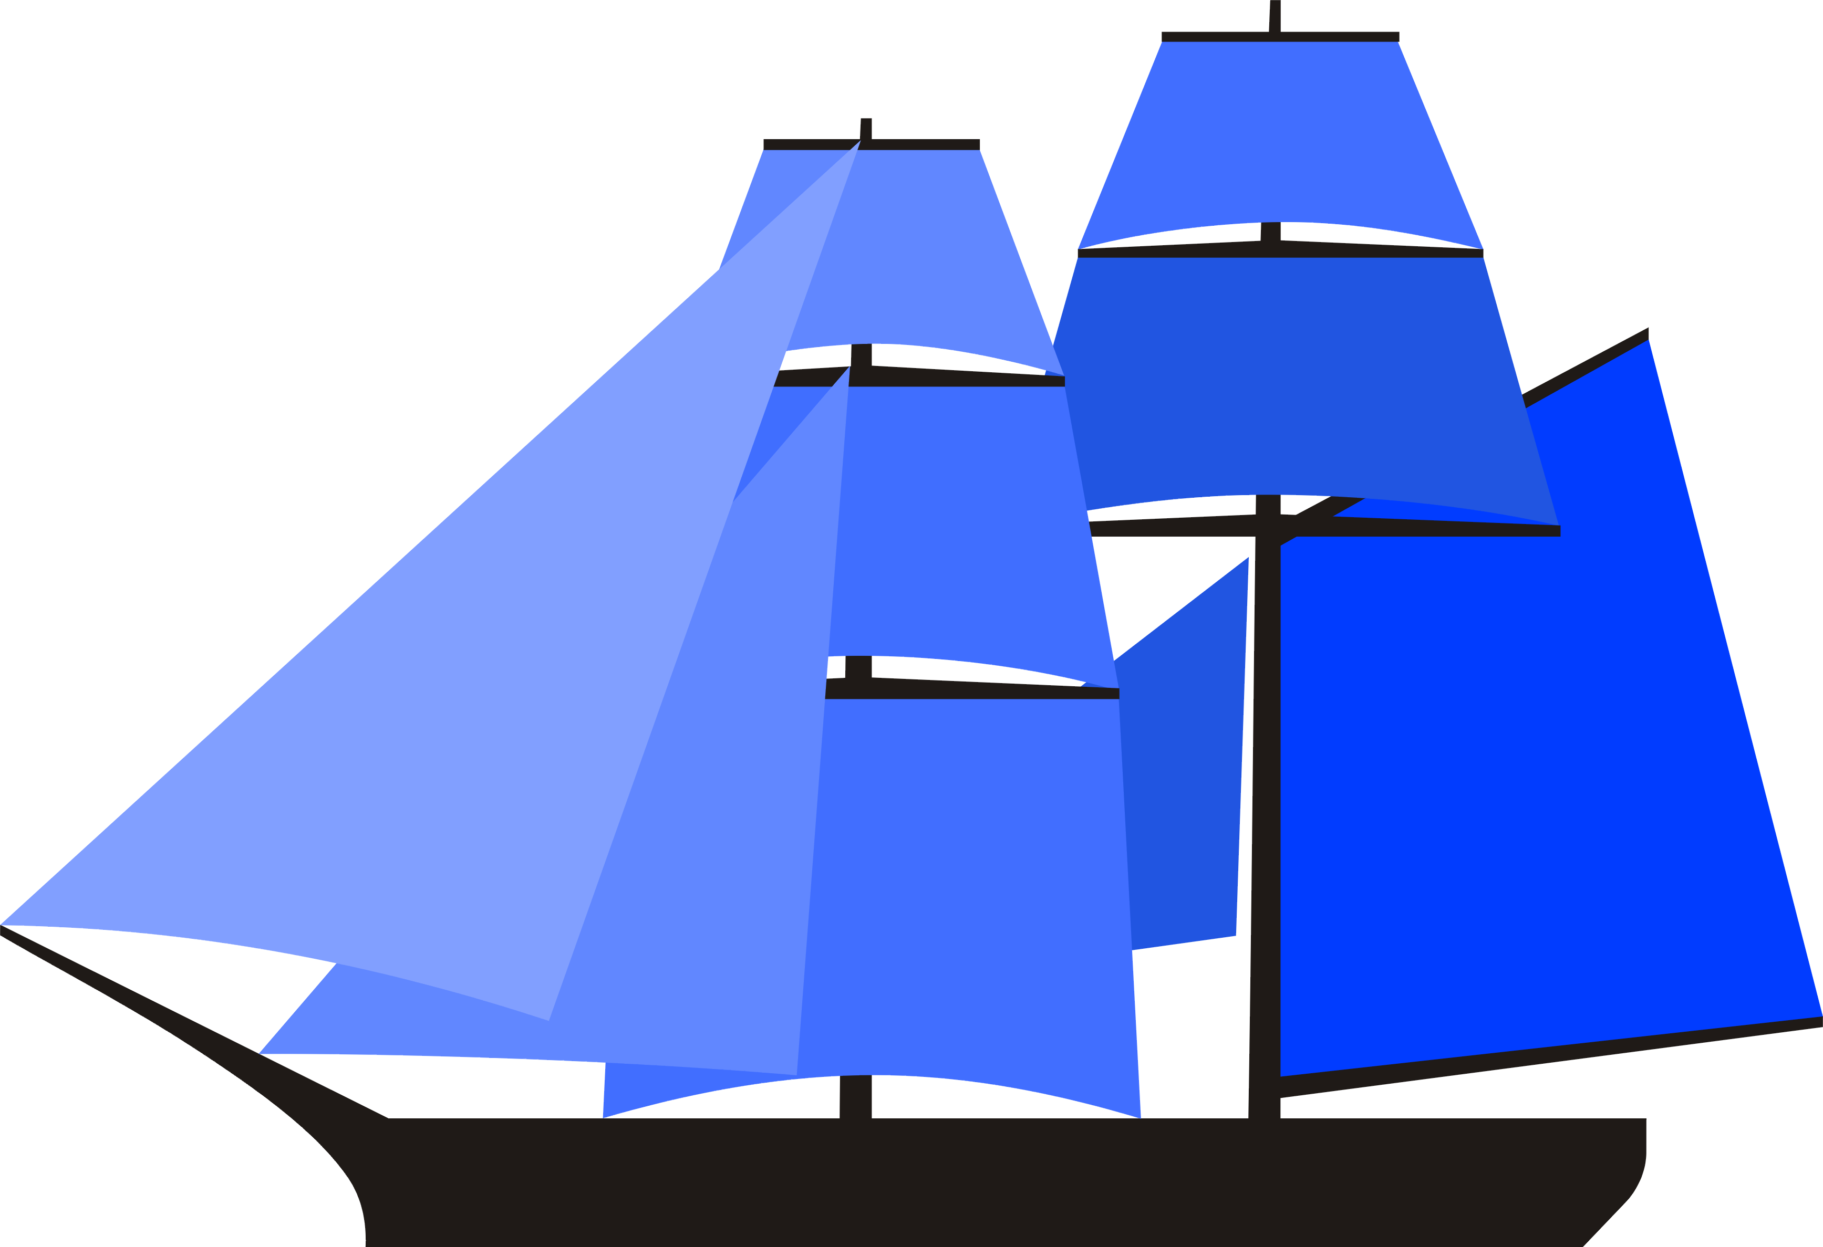
cheap, general good quality option. Limited to narrow or average width. 2 deck limit

Brigantine: More robust than a schooner, the Brigantine uses a square-rigged foremast and
mainmast rigged fore-and-aft with or without square topsails.
Sky Speed: 25 m/s, Water Speed: 10 m/s (ND: R = 3, D = 3, W = 5?)

Game Note: easier downwind that schooner, harder windward. More expensive, but have access to wide width. 2 deck limit

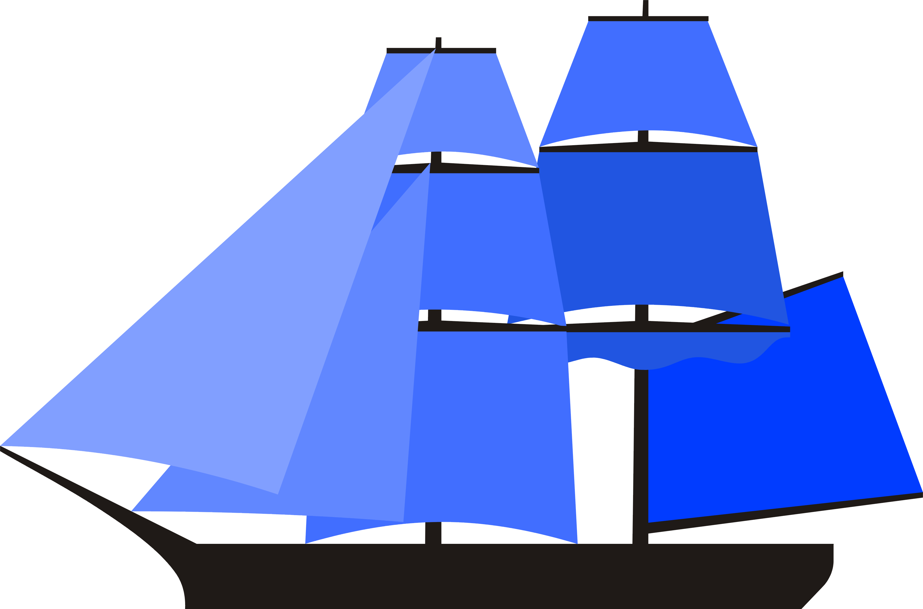
Brig: Typically slightly larger and more robust than a brigantine. square-rigged on both masts, with
additional "spanker" sail rigged fore-and-aft behind the mainsail.
Sky Speed: 25 m/s, Water Speed: 10 m/s (ND: R = 4, D = 4, W = 6?)

Game Note: Largest 2-mast option. Slightly better downwind than brigantine, but harder reaching. More expensive than brigantine as well as harder to operate, but gain a little extra capacity in comparison. 2 deck limit.

Medium, 3-mast:
Junk (Triple): Durable fore-and-aft rigged sails on each mast with reinforcing battens, requires less rigging than other options.
Sky Speed: 10 m/s, Water Speed: 5 m/s (ND: R = 5, D = 6, W = 7?)

Game Note: Slower, hard windward, but cheap, easy to maintain, and easy to
operate reach and ok downwind, and durable. 3 deck limit.

Schooner(Triple): Medium craft with all sails rigged fore-and-aft.
Sky Speed: 30 m/s, Water Speed: 15 m/s. (ND: R = 4, D = 5, W = 5?)

Game Note: Greater cost than 2 mast schooner, similiar otherwise other than being more
difficult overall. Still limited to narrow or average. 2 deck limit.

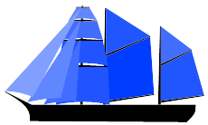
Barquentine: 3 mast craft with the foremast square-rigged and the mainmast and mizzenmast rigged fore-and-aft.
Sky Speed: 20 m/s, Water Speed: 10 m/s. (ND: R = 5, D = 4, W = 6?)

Game Note: Largest 'medium' class, able to be built wider than the 3 mast schooner, and more agile than the junk. 3 deck limit. Easier downwind than schooner, and easier
to crew than a full Barque.

Large, 3-mast:
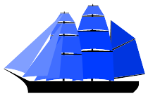
Barque(triple): Large three mast craft with square-rigged foremast and mainmast, with the mizzenmast rigged fore-and-aft.
Sky Speed: 15 m/s, Water Speed: 10 m/s. (ND: R = 6, D = 6, W = 7 ?)

Game Note: Must be average or wide width, 4 deck limit. Similiar to Barquentine but more
difficult to handle and crew. Harder downwind than full-rigged.

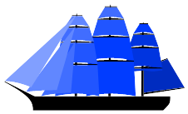
Full-rigged (triple): Large three mast ship, square-rigged on all masts, with and additional 'spanker'
sail behind the mizzenmast's sail.
Sky Speed: 15 m/s, Water Speed: 10 m/s. (ND: R = 6, D = 5, W = 7 ?)

Game Note: Must be average or wide width, 4 deck limit. Harder to crew but easier downwind than Barque.

Huge, 4-mast:

Barque (Quad): Large four mast craft with square-rigged foremast and mainmast, with the jiggermast rigged fore-and-aft.
Sky Speed: 20 m/s, Water Speed: 15 m/s. (ND: R = 7, D = 7, W = 8?)

Game Note: Must be average or wide width, 4 deck limit. Similiar to Large Barque but
much more difficult to handle and crew, and more expensive.
Harder downwind than full-rigged.

Full-rigged (Quad): Large four mast ship, square-rigged on all masts, with and additional 'spanker'
sail behind the jiggermast's sail.
Sky Speed: 20 m/s, Water Speed: 15 m/s. (ND: R = 7, D = 6, W = 8?)

Game Note: Must be average or wide width, 4 deck limit. Harder to crew but easier downwind than 4-mast Barque. Most Expensive.

